WELCOME TO THE PRODUCTION PROPOSAL
Production Proposal is the Internal Assessment for IB Theatre. Weighting: SL 30% or HL 20%

Just the BASICS of the Production Proposal

Imagine directing and producing a play how you have always imagined it!

Whether an SL or HL student, YOU will choose a published play text that you have not previously studied and formulate a vision for the design and theoretical staging of the entire play text for an audience. Your ideas are then presented in the form of a written Production Proposal. You are NOT required to stage the play.
- Your objective with the Production Proposal is to communicate your vision for the feasible staging of a play text for a live audience.
- You will approach this task using TWO perspectives - that of the director and that of the designer.
- Your finished work will be a maximum of 12 pages of written text and images, with written text not exceeding 4,000 words
- Your work will explain how performance and production elements could potentially work on stage to fulfill
theatre-maker intentions.
- You will write your proposal in the first person and include visual production design ideas and images to help communicate your vision.
- The production proposal articulates your vision for the final staging of the play text.
- You are not required to consider a hypothetical rehearsal process in this task.
- The list of any sources used is excluded from the page count.***

LET'S GET STARTED!

CHOOSING YOUR PLAY TEXT
You will need to choose a published play text you have NOT previously researched or practically engaged with for this assessment.
So, let's say you read Antigone in 9th grade and it is absolutely your favorite play of all time, or in IB Language and Literature you read A Doll's House in class, and during discussion, your imagination exploded with ideas to stage the play. Nope. You cannot use these scripts for this assessment. You must choose a script you have not studied or participated in as a produced play.*
HOWEVER, you can choose a play text you have not previously studied yet has been written by playwrights you have previously studied or encountered that you enjoy. This means if you loved Antigone you can look at the other plays written by Sophocles and consider those for this assessment or if you read A Doll's House by Ibsen you could choose An Enemy of the People or Hedda Gabler.

Look for play texts that INTEREST you! It is important that you choose a text that EXCITES YOUR IMAGINATION and that you feel passionate about transforming into a live theatre production.

THE TEXT ITSELF - can I change the words in the play to fit my ideas?
Just as in producing a play for the stage the the play text must remain unaltered.
You CANNOT edit, make additions or alterations to the original printed work.
You CAN communicate your vision for the staging of the selected play text, add additional moments of action on stage or introduce additional elements of design if this will help them to realize your vision for the staging.
- If you add moments or introduce design elements, they need to be appropriate to the play text and you must clearly identify and justify these additions.
- Your production of the play text does not necessarily have to be set within the original practice or style for which it was originally intended by the playwright.
- You are allowed to set the play in a contrasting practice or style in order to bring out a particular idea or theme appropriate to the work.
NEXT -

Now start organizing all your thoughts and imaginings into your Production Proposal!

Now that you have chosen your play, read it. Then read it again, and again.
- Remember to take notes as you read.
- Write down the ideas that come into your head as you read.
- Use post-it notes to mark important moments.

As you begin organizing your thoughts and ideas, keep in mind the structure of your Production Proposal and use the criterion as a road map for your work.
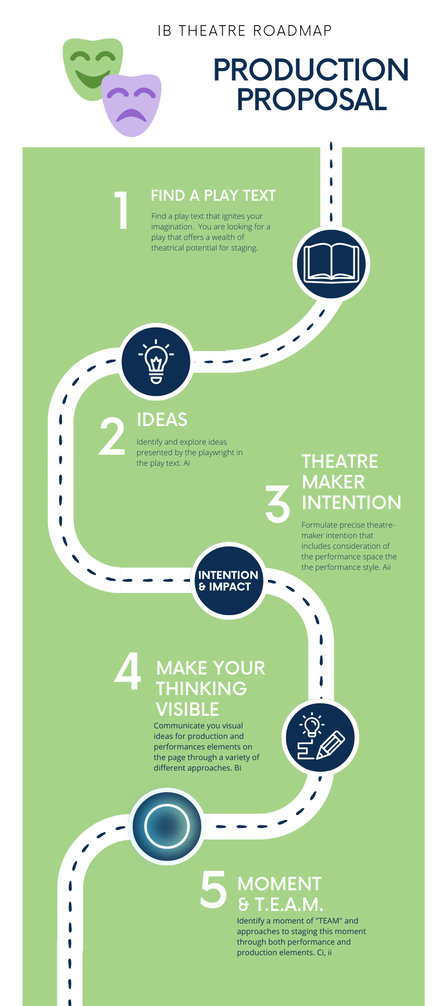

CRITERION A - IDEAS AND INTENTIONS
Criterion Ai**
- Your understanding of the play and of the ideas it deals with
- You are able to provide a detailed explanation of each of the key ideas and how the playwright is dealing with these ideas
- You are able to offer a justification and evidence from the play to prove this.
Criterion Aii
- Your interpretation of the key ideas of the play
- Your decisions on you you will stage your interpretation and the effect you want this to have on your audience
- Your chosen performance space
- Your chosen performance style
- Your decisions about how you will use performance and production elements to stage your interpretation

CRITERION B - THE PROPOSED DESIGN
Criterion Bi**
- That you refer closely to your theatre-maker intentions as explained in criteria A.
- Your explanation of how production elements will be used to meet your stated theatre-maker-intention
- Your explanation of how you will use production elements to turn your intentions into action
- Your production design ideas presented through visual that are clear, neat and have been carefully put together
NOTE - you do not have to be an incredible artist to present your visual design ideas. You can use mood boards for costumes, set design, and lights. You can include links for sound effects. You have to use your imagination and then make your thinking visible to the examiner.

CRITERION C - THE PROPOSED STAGING OF ONE MOMENT OF THE PLAY
Criteria Ci and Cii **
- That you provide an explanation of why the particular moment you have selected is a moment of "TEAM" - it is best to choose a moment that is no more than one or two aspects of "TEAM", at most, otherwise you might not be providing enough detail.
- That you can focus on the moment - although you might also refer to what happens just before and what happens just after, as this might also influence the audience's experience.
- That you provide an explanation of your theatre-maker intentions for this particular moment. These might be different from your overall intentions for the whole play (for example, in a play about war, this moment might be a moment of peace and. you may want to create this as a contrast to the overall feel of the play)
- That you offer an explanation of how you will use performance elements of "TEAM" in the text, into an experience and how this affects the audience (an effect of tension/emotion/atmosphere and/or meaning) when it is staged.
- You offer an explanation of how you will use production elements to turn the moment of "TEAM" in text into an experience and how this affects the audience (an effect of tension/emotion/atmosphere and /or meaning) when it is staged. You might also want to use visuals if these will help your explanations.

DESIGNResources for the Production Proposal HERE

So in a nutshell - your objective with the Production Proposal is to
- choose a play text that ignites YOUR imagination and offers a wealth of theatrical potential for staging
- identify and explore ideas presented by the playwright in the playtext
- formulate precise theatre-maker intentions that include consideration of the performance space the the performance style
- communicate visual ideas on the page through a variety of different approaches
- identify moments of "TEAM" and approaches to staging these through both performance and production elements.
IB and Double Dipping
If you choose a play script that you have studied or participated in as a produced play - this is called "double-dipping" and is not allowed in the IB Assessment process. It is the same concept in IB Language and Lit - the text you use for your IO cannot be used for the HL Essay nor can you use it for Paper 2. If you are in doubt about the play script you want to use - ALWAYS check with your instructor before you begin your work.

Final note - explain your choices. This cannot be stressed enough. Then - delete pages 1-5 of this document before you submit your first draft. You do not submit them to the IB. You are going to do a great job!

Production Proposal
Name of Play
Word Count

Criterion A: Ideas and Theatre-maker Intentions (allow about 4 pages)
Ai. Ideas/playwright's 'take
- What is the play about? What is the story that it tells? What ideas or themes are prominent in the play? Why do you think the playwright made those choices?

A.ii. Intentions for the staging of the play

Statement of Intention - What do you want the audience to take with them after they view your performance or do you want them to take action?

The Venue and Seat Arrangement
How will this impact the performance and support your theatremaker's intention?

The Context
Why is this important to your audience, the message of the play and how does it support your theatre maker's intention?
Do you need to produce your play in the time period it was written for or can you change the context of the setting?

The intended audience
Who will be impacted by your production? Is it being created for children? Inmates in a prison? Any adult? Teenagers?

The Performance style
What style of performance will you use with your actors? Realism, naturalism, theatre of the absurd, expressionism? Whichever you choose, and you must choose one, make sure to include why you chose it AND how it will impact the audience and support your TMI.

Section B: The proposed design

This is where you should let your creative juices flow! Use mood boards and images you find online (always cite them) to help explain your design choices.

The Set

Significant Props

Color Palette, Costumes, Makeup, and Hairstyling for all or selected characters

Name of character

Name of character

General Lighting States

Sound Effects - if they are significant

Music

Section C: The proposed staging of one moment of the play

Ci. Performance Elements to Effectively Create TEAM

The moment I have chosen……..page # to page # or You might want to take a photo of your script and insert it here.

You need to discuss and explain how will you use blocking, movement, the use of a prop, the character’s voice, or the nonverbal messages by using gestures to create TEAM in your chosen text.

C.ii. Production Elements Effectively Creating TEAM

You need to discuss and explain how your use of one or more of the elements listed below and how their use will create tension, emotion, atmosphere, or meaning. You do not need to create ALL elements of TEAM.

Set

Prop

Sound

Lighting

Costuming

Bibliography
Use MLA Citation Formatting

Lastname, C. (2008). Title of the source without caps except for Proper Nouns or: First word after colon. The Journal or Publication Italicized and Capped, Vol#(Issue#), Page numbers.
Lastname, O. (2010). Online journal using DOI or digital object identifier. Main Online Journal Name, Vol#(Issue#), 159-192. doi: 10.1000/182
Lastname, W. (2009). If there is no DOI use the URL of the main website referenced. Article Without DOI Reference, Vol#(Issue#), 166-212. Retrieved from http://www.example.com

