IB Theatre
Year 1
Assessment in 2024

Instructor: Ms. Nordleaf
Preferred Contact Information
gnordleaf@westsoundacademy.org
Course website: http://wsaibtheatre.org/
Preferred phone: 360-598-5954

COURSE DESCRIPTION

Theatre is a dynamic, collaborative, and live art form. It is a practical subject that encourages discovery through experimentation, the taking of risks and the presentation of ideas to others. It results in the development of both theatre and life skills; the building of confidence, creativity and working collaboratively. The IB Diploma Program Theatre course is a multifaceted theatre-making course of study. It gives students the opportunity to make theatre as creators, designers, directors, and performers. It emphasizes the importance of working both individually and collaboratively as part of an ensemble. It offers the opportunity to engage actively in the creative process, transforming ideas into action as inquisitive and productive artists.

Students experience the course from contrasting artistic perspectives. They learn to apply research and theory to inform and to contextualize their work. The theatre course encourages students to appreciate that through the processes of researching, creating, preparing, presenting, and critically reflecting on theatre as participants and audience members they gain a richer understanding of themselves, their community, and the world. Through the study of theatre, students become aware of their own personal and cultural perspectives, developing an appreciation of the diversity of theatre practices, their processes, and their modes of presentation. It enables students to discover and engage with different forms of theatre across time, place and culture and promotes international mindedness.

Students will find they often can choose the role that they wish to participate in - from a costume designer’s perspective to lighting or sound designer, writer, scenic artist, or actor to name a few.

ARTS AIMS
The aims of the DP arts subjects (dance, film, music, theatre, visual arts, and literature and performance) are to enable students to:
1. explore the diversity of the arts across time, cultures and contexts
2. develop as imaginative and skilled creators and collaborators
3. express ideas creatively and with competence in forms appropriate to the artistic discipline
4. critically reflect on the process of creating and experiencing the arts
5. develop as informed, perceptive and analytical practitioners
6. enjoy lifelong engagement with the arts.
THEATRE AIMS
In addition, the aims of the theatre course at SL and HL are to enable students to:
7. inquire into theatre and its contexts
8. develop and practically apply theatre performance and production skills and elements, led by intentions 9. create, present and evaluate theatre work both independently and collaboratively
10. acquire the perspectives and intentions of an internationally-minded theatre-maker
For HL only:
11. understand, appreciate and explore the relationship between theory and performance. 1

OBJECTIVES
Having followed the theatre course at SL or HL, students will be expected to fulfill the following objectives at assessment.
1. Inquiry
- Carry out academic and physical research and identify valuable information and resources to
support work in theatre
- Inquire into, and contextualize, the theatrical work and ideas of others
2. Development
- Develop informed and imaginative theatre-maker intentions for making and staging theatre
- Practically and collaboratively explore how performance and production elements combine in practice to create effective moments of theatre
3. Presentation
- Present theatre work to others in order to fulfill theatre-maker intentions
- Communicate theatrical ideas in a variety of forms, formats and contexts
4. Evaluation
- Reflect on feedback from others and consider their own development as theatre-makers evaluate the effectiveness of theatre work. 2
ASSESSMENT
The purpose of grading is to communicate achievement to students, parents, and other institutions about the work students do in class. The only feedback on students’ work that will be entered in the gradebook on FACTS is evaluative. The evaluation of student work is based on a set of standards, in line with the criteria for IB assessments.

As an IB course, students will complete both internal (assessed by Gretchen Nordleaf-Nelson) and external (assessed by International Baccalaureate) assessments.
The theatre syllabus at standard level (SL) and higher level (HL) is designed to follow a creative theatre- maker process that consists of four stages: inquiring, developing, presenting and evaluating.
Each of the four stages of the theatre-making process should be approached through the dynamic cycles of inquiry, action and reflection. Taught activities for each of these stages of the theatre-making process should include some of the following.
Each of the four stages of the theatre-making process [are approached] through the dynamic cycles of inquiry, action and reflection. Taught activities for each of these stages of the theatre-making process include some of the following.
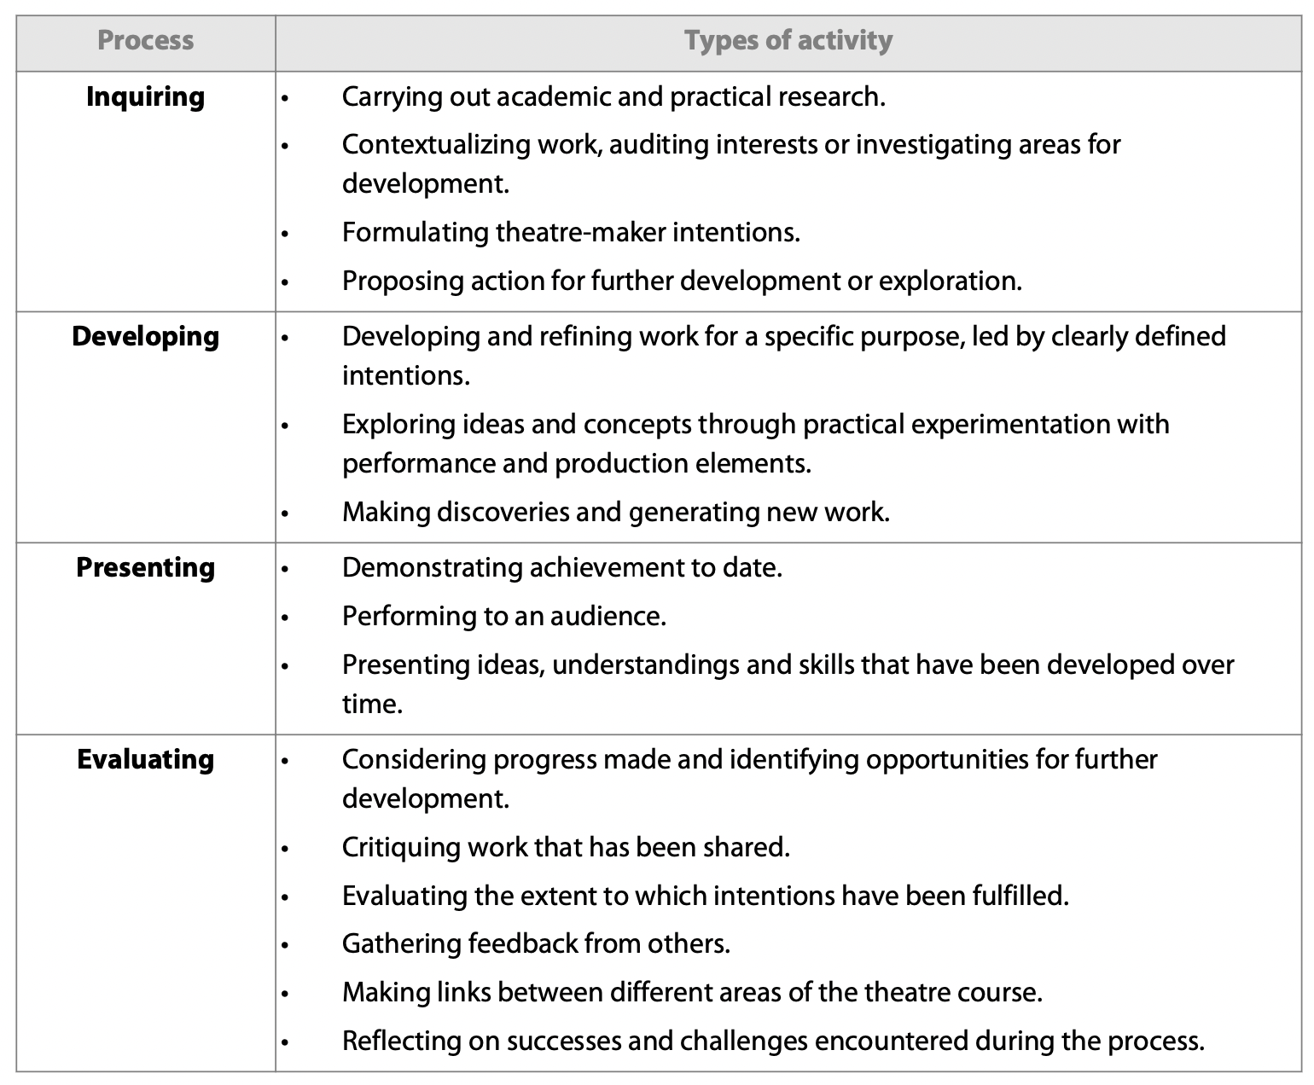

Assessment is an integral part of teaching and learning. The most important aims of assessment in the Diploma Programme are that it should support curricular goals and encourage appropriate student learning. Both external and internal assessments are used in the Diploma Programme. IB examiners mark work produced for external assessment, while work produced for internal assessment is marked by teachers and externally moderated by the IB.

There are two types of assessment identified by the IB.
- Formative assessment informs both teaching and learning. It is concerned with providing accurate and helpful feedback to students and teachers on the kind of learning taking place and the nature of students’ strengths and weaknesses in order to help develop students’ understanding and capabilities. Formative assessment can also help to improve teaching quality, as it can provide information to monitor progress towards meeting the course aims and objectives.

- Summative assessment gives an overview of previous learning and is concerned with measuring student achievement. 3

STUDENT SKILLS (15%) Student skills including focus, preparation, responsibility, cooperation, collaboration, and time-management are strongly correlated with academic success. These are also marked using the student skills rubric each week. Full participation requires conscientious and consistent preparation. Consistently turning quality work in on-time and participating actively in classroom activities will lead to earning the full mark.

Focus:
- Listens Attentively
- Participation Enhances Classroom Learning
Responsibility:
- Comes to class prepared & engaged
- Treats others with kindness
Follow-Through:
- Completes work and turns in work on time
Strives to produce quality work
Collaboration:
- Listens to presenters & classmates offers ideas and shares the workload on project-based assessments.
Growth Mindset
- Demonstrates persistence and resilience, open-minded in the face of challenge

Formative Assessment 50%

IB Journal
This is a reflection journal, which includes the class opener, class notes, and class session reflections for each class session. This routine writing assignment collection will be checked weekly and earn up to 30 points per week for completion. There will also be weekly blog posts in this portion. The format of the reflection journal is flexible. Students can choose to handwrite their journal or create a digital format within provided guidelines.

Class Discussion Content
This is an essential component of student work. Students earn points for speaking in class discussions. The scores reflect the length and depth of student contribution. The individual student spoke at least twice.

Play Reading Reports, Reading Assignments,
Play Reading Reports are designed to enhance and strengthen the theatre literature canon of each student. They will be assigned quarterly. Vocabulary quizzes - These are quick checks on comprehension and completion. They will be assigned regularly as needed.

Summative Assessment 35%

Projects that will be building skills to completed
Solo theatre piece: Students at HL research a theatre theorist they have not previously studied, identify an aspect(s) of their theory and create and present a solo theatre piece (4Ð8 minutes) based on this aspect(s) of theory.

Assessment objectives are common across SL and HL.

The curriculum in Year 1 will prepare student for the following topics and assessments in Year 2:

PRODUCTION PROPOSAL
Students at SL and HL choose a published play text they have not previously studied and formulate a vision for the design and theoretical staging of the entire play text for an audience. These ideas are presented in the form of a proposal. Each student submits the following.
- A production proposal (a maximum of 12 pages of written text and images, with written text not
exceeding 4,000 words) plus a list of all sources used. SL 30% HL 20% Assessment completed in 2024

RESEARCH PRESENTATION
Students at SL and HL plan, deliver and video record an individual research presentation (15 minutes maximum) in which they provide evidence of their academic and practical exploration and learning of a world theatre tradition they have not previously studied. Each student submits the following.
- A video recording of the student’s research presentation (15 minutes maximum).
- A list of all sources cited, and any additional resources used by the student during the presentation. SL 30% HL 20 % Assessment completed in 2023 Year-end final summative project.

COLLABORATIVE THEATRE PROJECT: COLLABORATIVE PROJECT
Students at SL and HL collaboratively create and perform an original piece of theatre (lasting 7–10 minutes maximum) created from a starting point of their choice. The piece is presented to an audience as a fully-realized production. Each student submits the following.
- A project report (a maximum of 10 pages of written text and images, with written text not exceeding 4,000 words) plus a list of all sources used.
- A video recording of the final piece (7–10 minutes maximum).
SL 40% HL 25% Assessment completed in 2024
SOLO THEATRE PIECE (HL ONLY)
Students at HL research a theatre theorist they have not previously studied, identify an aspect(s) of theory and create and present a solo theatre piece (lasting 4–7 minutes maximum) that demonstrates the practical application of this theory to a theatre piece for an audience. Each student submits the following.
- A report (2,500 words maximum) plus a list of all primary and secondary sources cited.
- A continuous unedited video recording of the whole solo theatre piece (4–7 minutes maximum).
HL only 35% Assessment completed in 2024

ENGAGING WITH SENSITIVE TOPICS

Studying theatre allows the opportunity for students to engage with exciting, stimulating and personally relevant topics and issues. However, it should be noted that often such topics and issues can also be sensitive and personally challenging for some students. The teacher is aware of this and will provide guidance on how to approach and engage with such topics in a responsible manner. Consideration is given to the personal, political, and spiritual values of others, particularly in relation to race, gender, or religious beliefs.

As part of the collective consideration of West Sound Academy, theatre students will be supported in maintaining an ethical perspective during their course. The instructor will be vigilant to ensure that work undertaken by the students does not damage the environment, include excessive or gratuitous violence or reference to explicit sexual activity.

INCLUSIVE ACCESS ARRANGEMENTS

Inclusive access arrangements are available for candidates with access requirements. Standard assessment conditions may put candidates with assessment access requirements at a disadvantage by preventing them from demonstrating their attainment level. Inclusive access arrangements enable candidates to demonstrate their ability under assessment conditions that are as fair as possible.

The IB document Access and inclusion policy provides details on all the inclusive access arrangements available to candidates. The IB document Learning diversity and inclusion in IB programmes outlines the position of the IB with regard to candidates with diverse learning needs in the IB programmes. For candidates affected by adverse circumstances, the IB documents General regulations: Diploma Programme and the Diploma Programme Assessment procedures provide details on access consideration. 4

REQUIRED MATERIALS:  - Laptop  - Laptop charger (You are required to bring this to class everyday)  - Internet access  - journal  - a folder or binder for keeping class materials  - Computer storage device for your videotaped assignments.  - a notebook  - internet access  - pencils or pens (blue or black) | TEXTS:  Will be supplied by the instructor until the new IB Theatre Text is available from the International Schools Theatre Association later this Fall.  WORKSPACE:  If and when you are in the virtual classroom you will need to make sure you are in a space where you can move around.

1 Diploma Programme Theatre Guide First Examinations 2024 (2022). Cardiff : International Baccalaureate Organization, p.12
2 Diploma Programme Theatre Guide First Examinations 2024 (2022). Cardiff : International Baccalaureate Organization, p.13
3 Diploma Programme Theatre Guide First Examinations 2024 (2022). Cardiff : International Baccalaureate Organization, p. 25
4 Diploma Programme Theatre Guide First Examinations 2024 (2022). Cardiff : International Baccalaureate Organization, p. 26

Course Expectations, Guidelines, and Procedures for the In-Person and Zoom Classroom
will be provided in a separate document.

IB Theatre YR1
2022-23
Acknowledgement Form

PLEASE RETURN THIS FORM ONLY – Thank you.

By signing this form, you are acknowledging and agreeing to the above course syllabus.

Today’s Date____________________

Student Name________________________________________________________________________

Student Signature_____________________________________________________________________

Parent Name_________________________________________________________________________

Parent Signature______________________________________________________________________

